**Research without borders**



***Malawi Medical Journal* – Blantyre, Malawi**

**Hoglah Dasari –May 7 – 18 2018**

**knowledge sharing is Worth Gold**

*“Sometimes it's necessary to go a long distance out of the way to come back a short distance correctly.” ... Selected*

A special thanks to the Research Without Borders team (Ylann and Domiziana) who takes all the efforts to prepare the team, taking interviews, making all the arrangements for the colleagues to travel to make this program a great success. It’s a wonderful skill based volunteering program giving opportunity to all publishers to share critical skills and capacity building with African health journals.

This program clearly relates to Boundarylessness, going beyond borders to exchange the knowledge and highlights the importance of sharing the knowledge.

I wish Research Without Borders team a great success.

**Preparations before Travel**:

Scheduling calls with the Editor in Chief

Understand the requirements of the team

Fixing up the meetings, dates and timings

Preparing the reports

Preparation of number of presentations as per the requirement of the MMJ team



The Malawi Medical Journal is a peer reviewed, open access, quarterly, general medical journal, published by the University of Malawi College of Medicine and the Medical Association of Malawi. The MMJ serves as a forum for the dissemination of findings of health-related research undertaken in Malawi and beyond to health workers. It incorporates original research studies, policy analysis, case reports, literature reviews, and occasional special features. It is published electronically on a quarterly basis. To better serve our main target audience in Malawi and sub-Saharan Africa, there are plans to revive a regular print version of the MMJ soon. (MMJ)

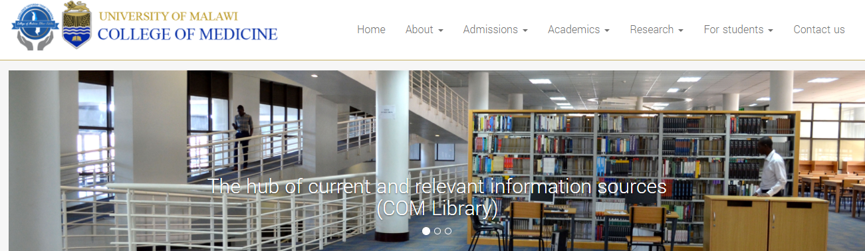

The College of Medicine (CoM) was established in 1991 as a constituent college within the University of Malawi (UNIMA). It is the only medical school in Malawi. It’s wonderful that the MMJ office is in this beautiful college.

**The Malawi Medical Journal Team:**

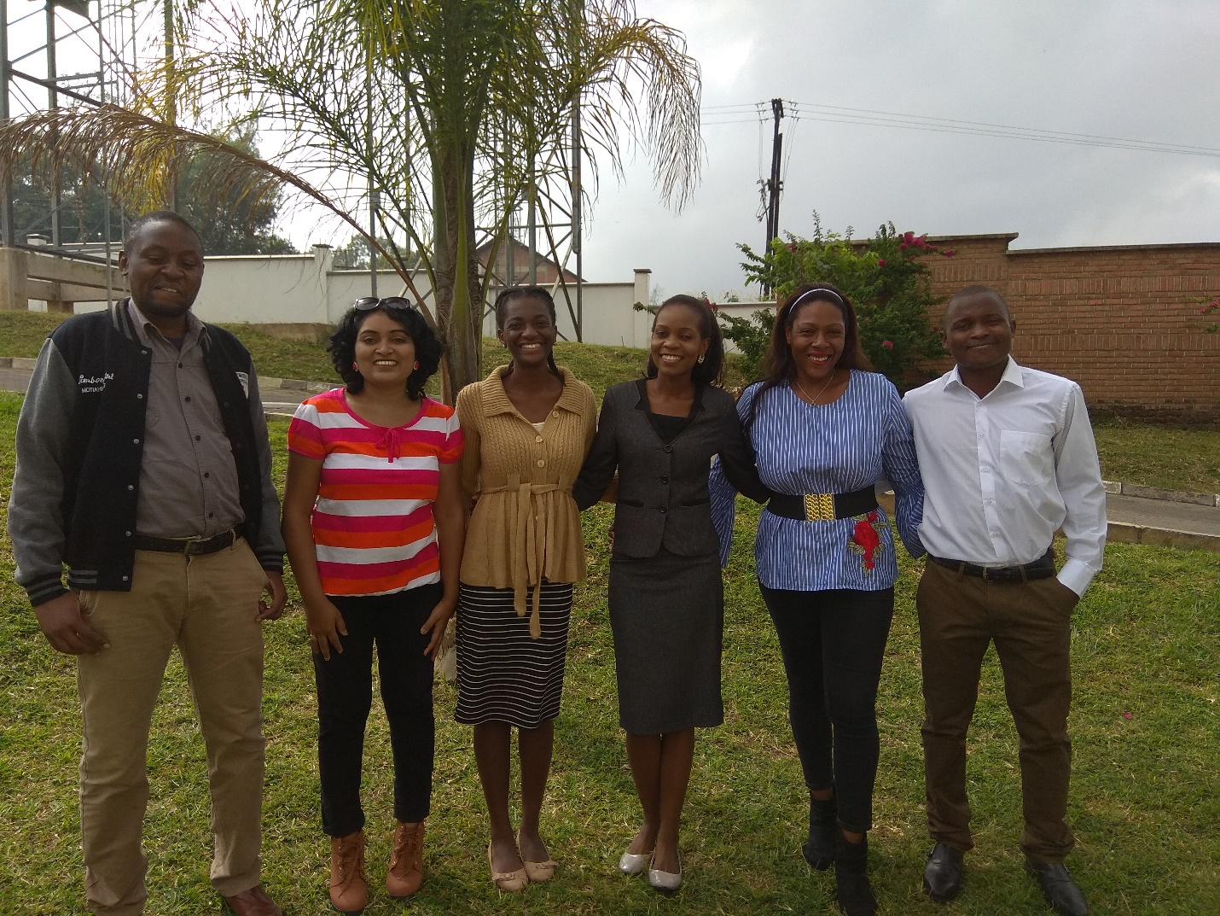

It’s such wonderful team of young aspirant and talented people, who are very enthusiastic and eager to learn and very keen to implement the ideas that were shared with them. I had meetings with each of the MMJ member for all the two weeks in MMJ office and in Lucinda’s office in College of Medicine.

Objectives

To work closely with the MMJ team, understand the need of the team and the journal, develop the required strategy for the journal to achieve the goals and prepare the required documents. Assist the team to achieve the set goals by giving them the required information, guide the team for marketing and to provide steps to promote the journal. To do Author Workshop and Seminar for the College of Medicine.

Activities covered in two weeks:

1. **Details to Open Access:**

Explained different types (Gold and Green) of open access, license, advantages, copyright details, Funding bodies, facilitating open access policies and tips to publishing gold open access.

1. **Impact Factor:**

Explained what is IF, how to calculate IF, status of MMJ in terms of IF and its fluctuations. How MMJ is performing, is growth negative/positive. Showed reports that MMJ is declining in terms of IF from previous years. Explained how to grow the IF. By acquiring more review articles, more special issues. The quality if the content plays a very vital role in increasing the IF of the journal. Different factors are involved in increasing the IF of the journal. Explained how to get more review articles.

1. **Quality content vs quantity: Types of submissions to increase the IF and citations:**

Explained the importance of having quality content rather than increasing quantity. To increase submissions of review articles, original submissions, and to have more special issues. Explained about having small Thematic issues which can increase the citations and IF as well. The Journal Editor should play a very vital role in acceptance of the articles. Quality is more important than do a favor to authors or colleagues. Editors not to show sympathy to colleague’s submissions or known authors as this would damage the quality of the journal and would affect the IF.

1. **Citations and its importance** – Citation plays a key role for any journal. Citations and IF go hand in hand. Self-citations to be avoided as much as possible. It’s important for MMJ team to do more journal marketing so that articles get enough citations. Journal visibility is more important to get the content from different community. Instructed team to use Mendeley, LinkedIn, Twitter to promote the journal and articles. The more the journal is promoted, the more scientific community will be able to see the articles.
2. **Creating revenue for the journal:**

Since there is zero revenue and many of the editors don’t get paid, they need budget for many things. Instructed the Journal editor, since it’s open access journal, they can start collecting a small amount from authors, later they can revise it again. Instructed the team to have color figures and have a minimal cost for figures as well. They can wave the cost for 1st 2 figures and charge for the rest of the figures. This will help as of now to generate revenue for the journal which they can use.

1. **Article types and their importance for the journal:**

To remove the submission category “Poetry” as they don’t add any value to the journal and to drastically reduce the acceptance of “Case reports” as well as not much value is added to the journal and to increase the IF. Thematic Issues can be a collection of 4 to 5 submissions from same topic and need not publish them as special issues but can be done along with the regular content but adds value to the journal and increase the IF. To increase number of review articles and special issues.

1. **How to get hot topics for the journal and its Importance:**

Editors can generate the topics from the keyword analysis and then see which are the topics they can start developing as special issues. Taught on how to do keyword analysis and hot topic analysis. By doing this, editors would know, which are the hot topics in their field which they can concentrate more and get the content. These topics, they can prepare call for papers and host them on journal website, college homepage for authors to submit their papers.

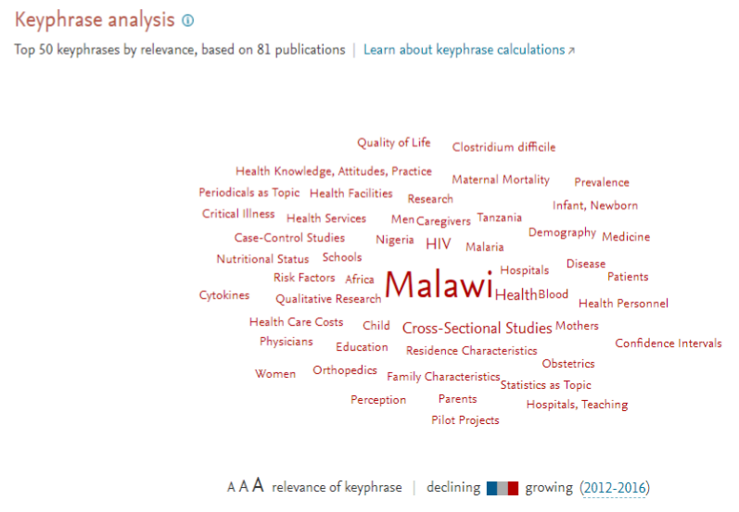

1. **Aims and Scopes of the journal – Revamping as per the requirement:**

Explained the importance of journals Aims and Scope. This is what will get authors to submit their papers to the journal. There are many points which were irrelevant for the journal and hence, we revamped the entire content and added more specifics into, what type of content we are considering, why, who should submit to the journal, what are the article types etc. A very useful and practical approach is considering research questions in terms of aim(s) and objectives. Understanding of Aims, Objectives, Goals, Scope and limitations will help authors better prepare themselves and keep best foot forward! If the aims and scope of the journal are correct, we will get the expected articles for the journal.

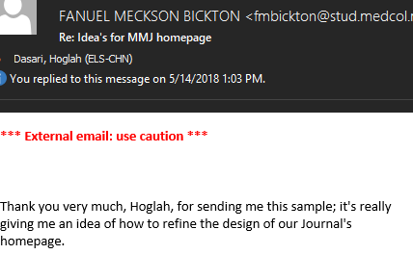

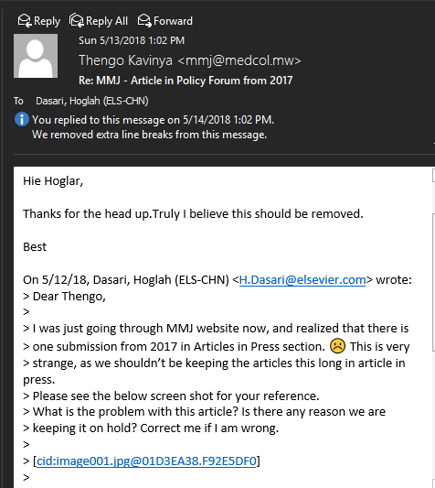

1. **Session on Ethics and Revamping the Ethics document:**

Explained the importance of Ethics in publication. The do’s and don’ts, the COPE, the consequences of ethics issues etc. All the major Ethics issues have been covered. The MMJ Ethics document was given to me for updating with relevant information however, since it’s part of Ethics team, I have sent the document to them for their inputs. Journal editors are responsible for the integrity of the record they publish in their journals. Thus, the ethical aspect of publishing is an important part of editorial work. Ethical publishing is particularly important in small and developing communities. Short term solution will bring in long term consequences – explained in detail.

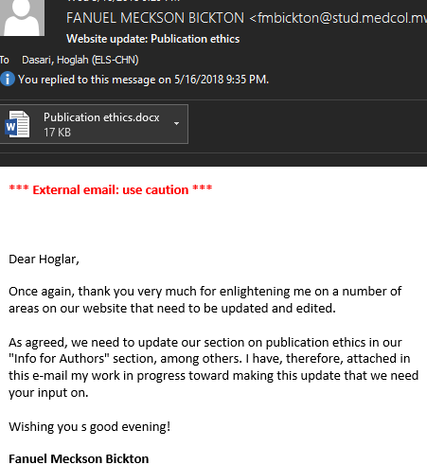

1. **Reports on Malawi Medical Journal, College of Medicines**

Prepared reports for MMJ and College of Medicine on their performance. The below illustrations clearly show what subject areas the university is publishing and the citations they are receiving.

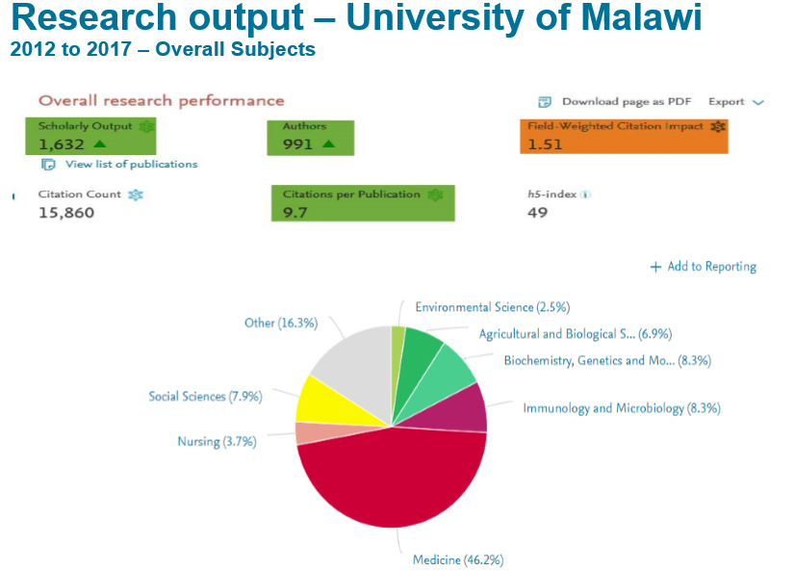

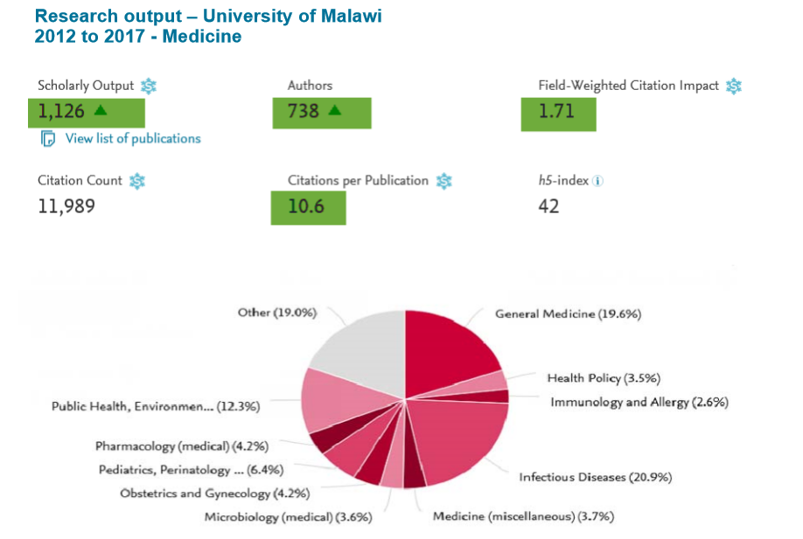

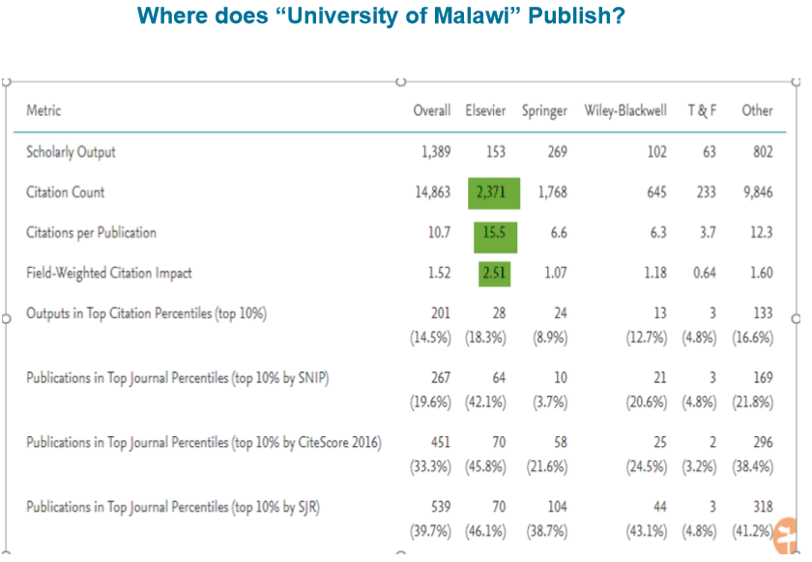

1. **Importance of Review process:**

The peer review process for journal publication is essentially a quality control mechanism. It is a process by which experts evaluate scholarly works, and its objective is to ensure a high quality of published science. Explained to the MMJ team as to how important review process plays a major role on quality of the content. MMJ has issues with finding reviewers, hence suggested to the team to request authors to suggest the reviewers and meet the below criteria:

Authors need to submit the names and institutional e-mail addresses of several potential referees. Suggested reviewers must not be from your own institution and must not have collaborated with you at least during the last five years, and should not already have provided you with comments on the manuscript. You should indicate the expertise of the referee in relation to the topic of your manuscript. You may also suggest up to two referees to exclude due to conflicts of interest. Editors will have the rights to decide whether to invite these reviewers.

Also, informed the team that they can chose 2 reviewers from authors list, and 2 reviewers from their own list and get the reviewer comments which will justify equally. Also, editors can keep some alternate reviewers for themselves to use in case of unresponsive editors. Also, explained if editors submit their own papers, they should be reviewed by other editors of the journal. Regularly update referee affiliations. Maintain a good database of potential reviewers.

1. **Engage in social networking communities:**

Explained about journal visibility and its importance to the team. Explained about Mendeley, LinkedIn, Altmetric, Twitter Usage, Facebook, college websites, News channels, Newspapers, Conferences. It’s important to have author identifier ORCID to distinguish themselves and their work from that of all other researchers. Explained about research gate, science blogs etc.

1. **Marketing Strategy and its importance**

Revamping the document and checking what has been done by previous volunteers and steps taken by MMJ and what further can be done. Thengo has a Journalism background, he has worked with local newspaper and radio company as well. Hence, I have encouraged him to use his skills for the journal and do much more marketing of the journal through these channels. Explained about Mendeley, LinkedIn, Altmetric, Twitter Usage, Facebook, college websites, News channels, Newspapers, Conferences. Took session in detail for all these, what to do, how to do, when to do and where to do. Adding banners on Journal Homepage, college website, advertisement in Radio, News Letters, News papers

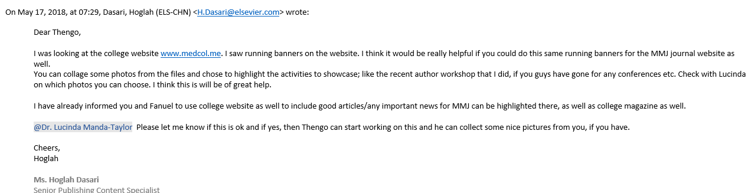

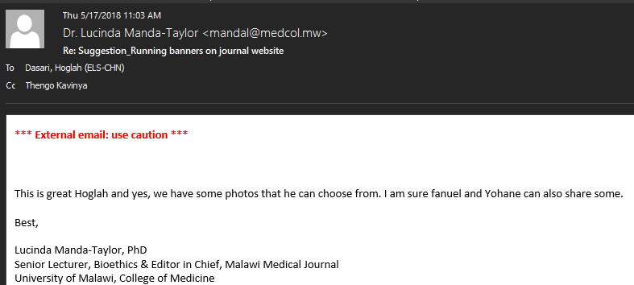

1. **Importance of Special Issues and its role in Impact Factor and Citations,**

Importance of Special Issues and its role in increasing Impact Factor and Citations, how to initiate special issues, discussions to be done, how to acquire GEs, etc., Special issues usually attract more attention than regular issues, perhaps because the articles may be commissioned. Consequently, the articles are often read more and highly cited.

Special issues can also be good for the discipline, drawing attention to a topic. However, too many special issues can lead to copy backlogs if not carefully managed because they add an issue worth of content on top of the usual flow of submissions. A special issue enables a journal to publish papers focusing on specific themes, often related to a “hot topic” in that field of research. A special issue can deliver several benefits to the journal, such as:

* Generating publicity and raising awareness of the scope of topics covered in the journal
* Encouraging new authors to submit their work
* Attracting new readers and new subscribers to the journal
* Boosting downloads and citations
* An opportunity to experiment with innovative or unusual content

When selecting a topic for a special issue, ask yourself the following:

* Is the suggested topic appropriate given the journal’s aims and scope?
* Is the topic of significant interest to the journal’s primary reader base?
* How “hot” will the topic be by the time the issue is published?
* How many special issues has the journal already published in recent volumes?

And remember the logistics. Consider:

The time required for any “call for papers” to circulate around the research community

An appropriate submission deadline

The journal’s page budget (where necessary)

The time taken for papers to be peer-reviewed and any required revisions to be made

The publication schedule of forthcoming issues or subsequent volumes

The role of a guest editor

Many journals appoint a specialist in the subject area to act as guest editor of the issue. It is important that guest editors understand the commitment they are making to the journal; they must be able to dedicate themselves to the project. For the process to run smoothly, communication is key – the guest editor should maintain regular contact with the editor, providing updates on the progress of the issue.

The specific tasks assigned to a guest editor will depend on the journal in question; however, publisher provides documents specifically created for guest editors which contain detailed information and guidance on their role.

1. **Author Workshop:**

It was full day Author Workshop, it was welcomed very well by all the College of Medicine and has been mentioned that this was the first time, an author workshop was conducted at College of Medicine and I have received a very positive response from the college and the team. Also, explained about How to turn thesis into an article; which was very helpful to the audience. Videos related to importance of language and why does scientist publish, were played. Below are the broad topics which were covered; Number of activities were conducted for the attendees.

* **Academic Publishing**
* **University of Malawi output**
* **Why is it so important to write a GOOD paper?**
* **How to write a good manuscript**
  + Preparations before starting
  + Building your article
  + Some technical details that need special attention
  + Language
  + **The review process**
  + **Ethical considerations**

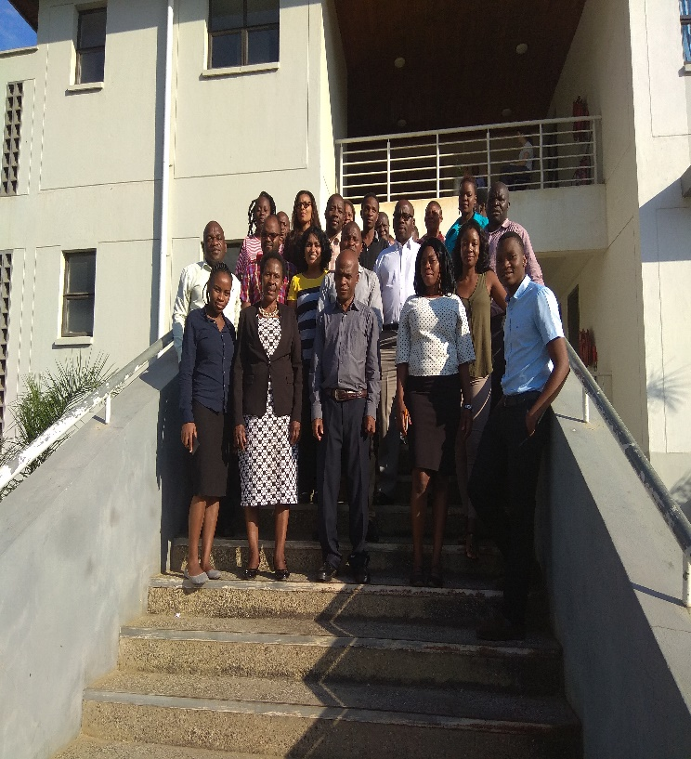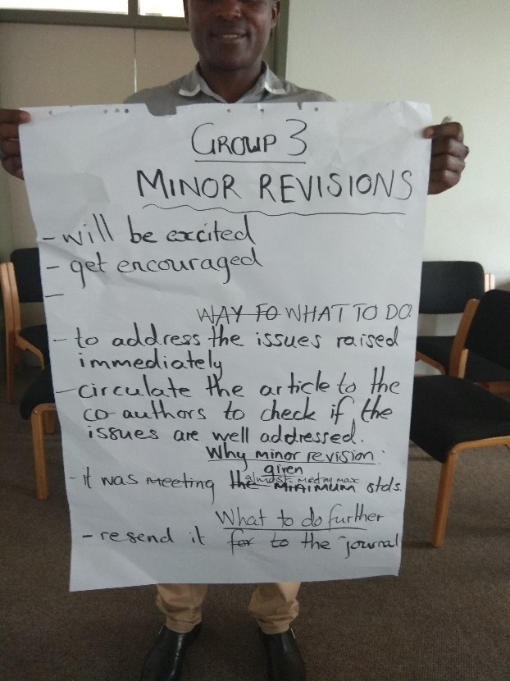

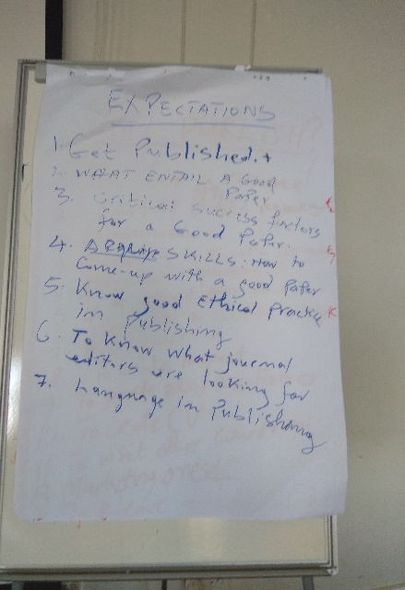 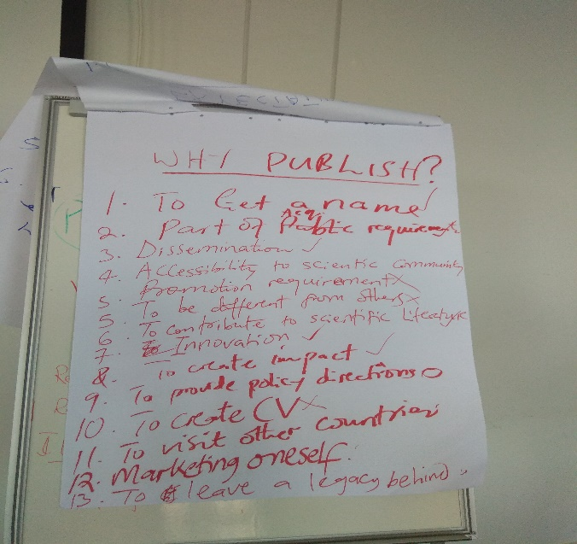

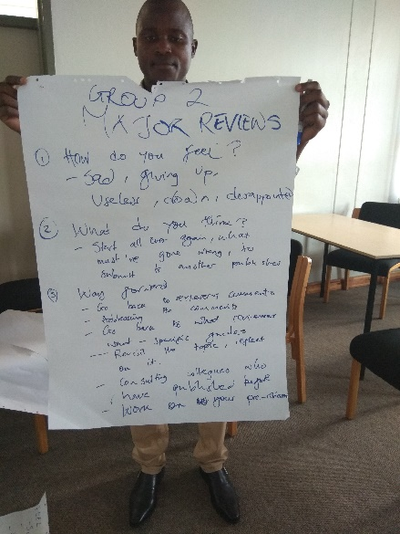 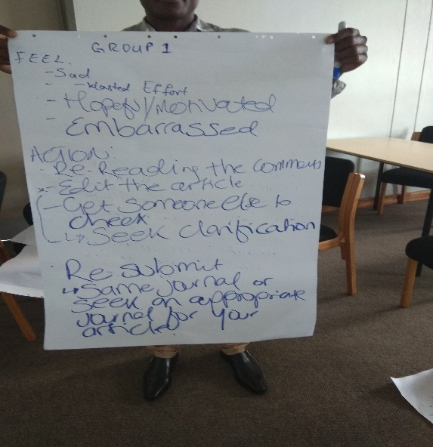

1. **Seminar @ College of Medicine:**

This was also the first time, where the college has invited Elsevier Volunteer to conduct a seminar for the College of Medicine. I had spoken about **“Publishing Content Specialist Team-An Insight Understanding the importance of academic publishing -why to publish? And Ethics of Publication.”**

The College has given me a very warm welcome and arranged everything for the seminar and it was a pleasant surprise for me to see many doctors attending this seminar and asking many questions.

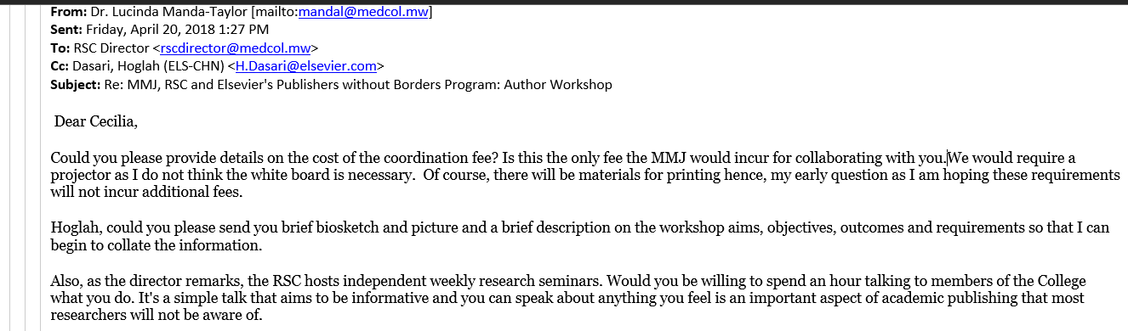

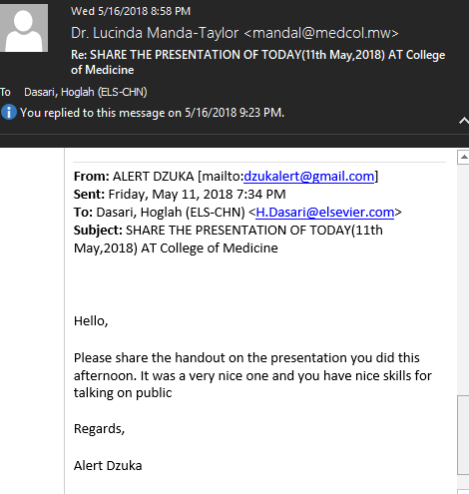

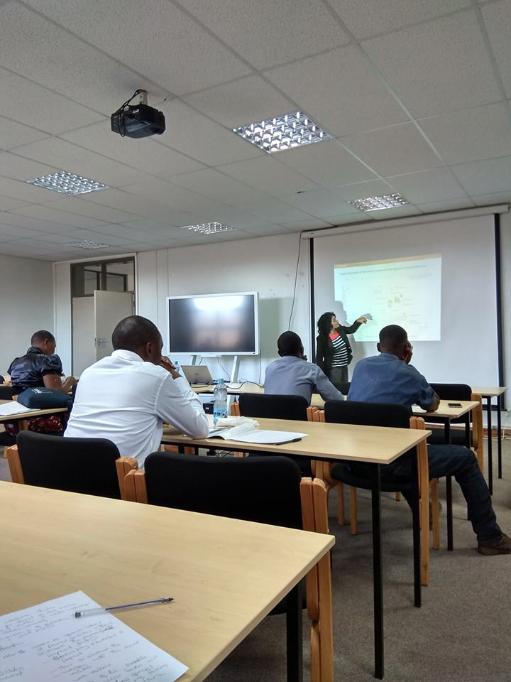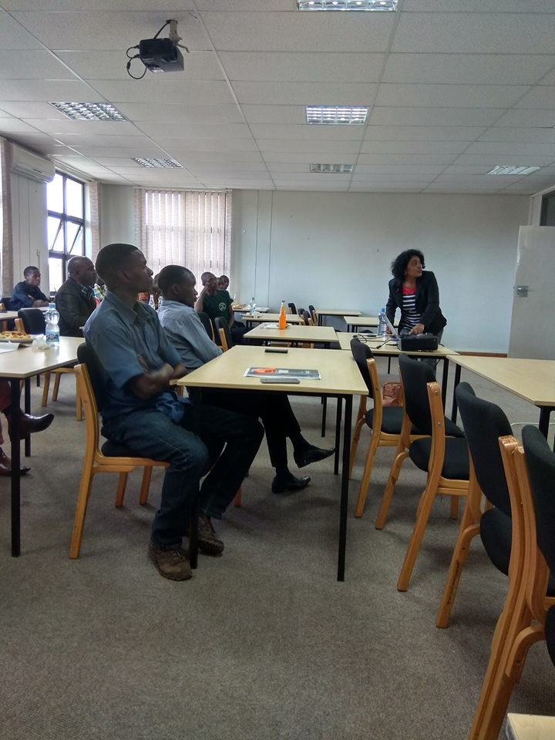

1. **The role of Journal Editor**

I had also to give some insights into the role of Journal Editor in developing the Malawi Medical Journal. The importance of accepting quality submissions was one of the major topic. I was also able to help the Journal Editor to set up the handover meetings and smooth transition of editorial activities to New Journal Editor. Also, explained about Journal growth and development and Authorship and responsibilities.

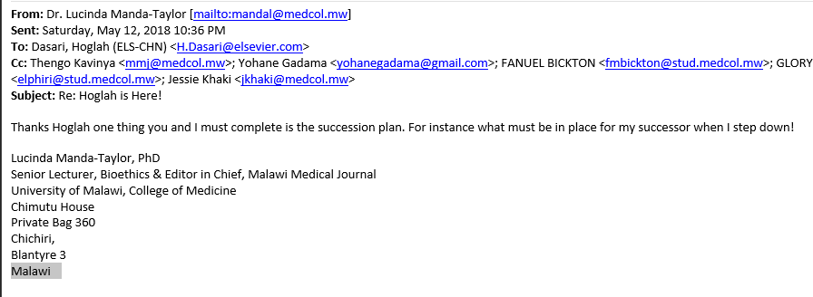

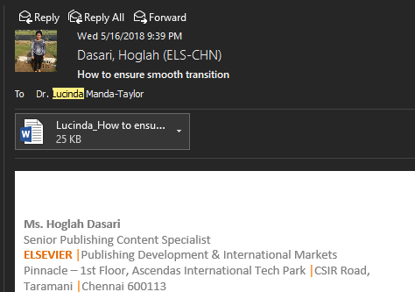

1. **Successful grant writing:**

Explained in detailed about grant writings and provided them handout materials as well.

1. **Call for papers, Importance, and preparation:**

I have explained what are call for papers, importance of it, how to prepare them. Now they have prepared a call for papers for one their upcoming special issue and hosted it on journal homepage.

Guest editors may choose to directly commission papers from colleagues in the field or they may choose to put out a call for papers. You may be asked to send the call for papers to previous submitters via a broadcast email. Be careful that this communication is worded appropriately. A call for papers is open to everyone; they do not want to give the impression that one individual is being singled out for special invitation. The call for papers should also clearly state that papers will be peer-reviewed and may be rejected. If the guest editors are soliciting proposals for submissions, you may be asked to keep track of these. Be sure to keep a record of which proposals the guest editor accepted so you know which submissions to accept. Timelines are very important and crucial.

1. **Altmetric session and DOI registration:**

Explained about Altmetric, how MMJ articles are performing, and how Malawi Medical team can

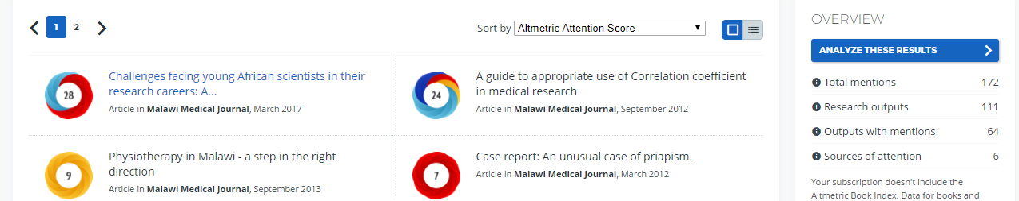

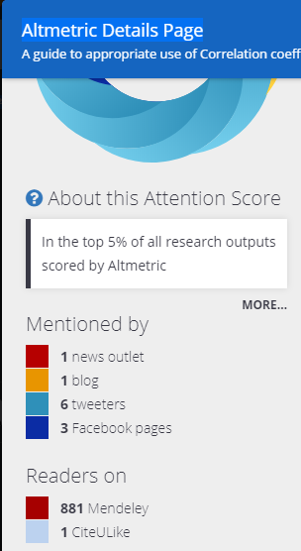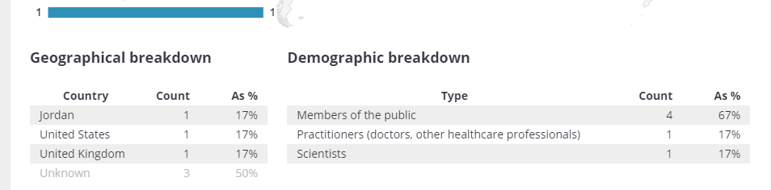

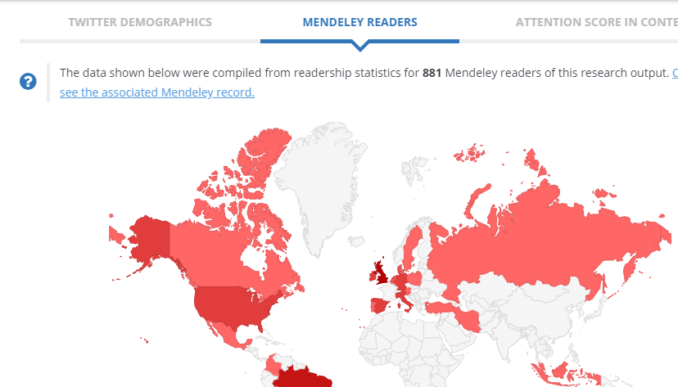

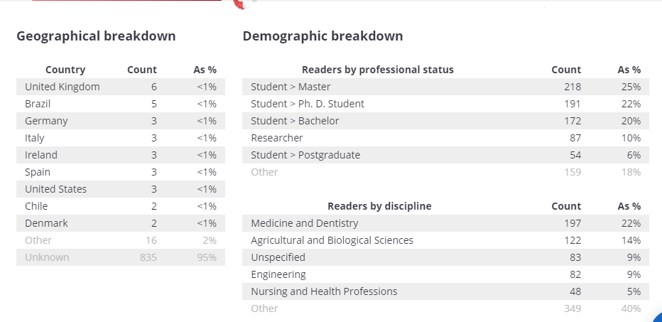

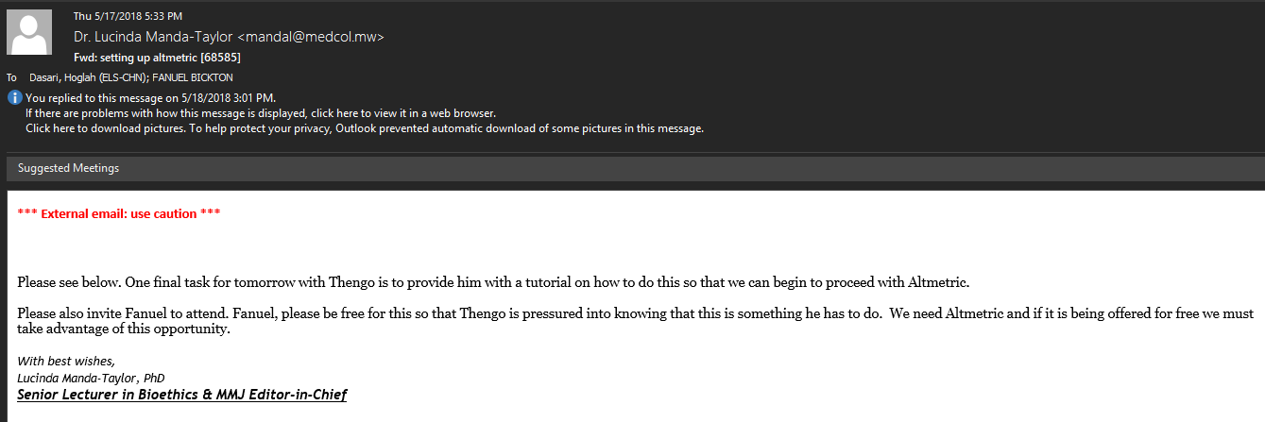

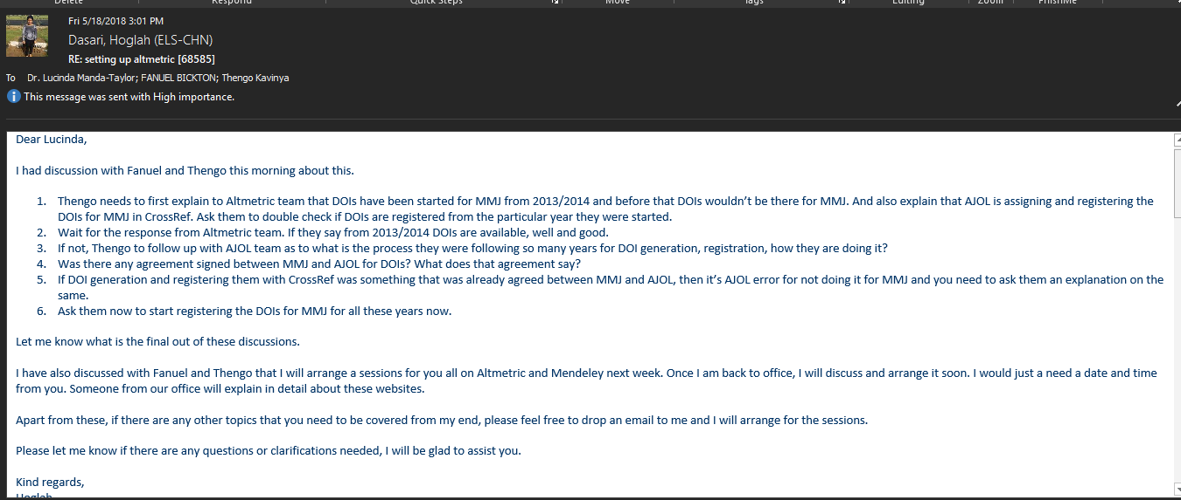

1. **Scopus, Scival and Science Direct:**

How to use, how to track the articles, how to get reports, how to get top cited articles, Scopus Analysis, Special issues verses regular issues, top institutes, regions from where articles are coming more etc.

1. **Mendeley:**

Importance of Mendeley, managing and sharing research paper and collaborating online. Asked MMJ to create Mendeley accounts and then post the articles and to start having discussions. All MMJ editors have now account.

1. **Understanding and differentiating the roles and responsibilities of each MMJ editor**:

I tried to understand each of the MMJ editor’s roles and responsibilities. I found that majority of them are doing same work. Hence, I had to sit with each person and explain what they should be doing for MMJ. Drafted their roles and responsivities as well. There should be a demarcation of the duties performed by each editorial team member. Helped few editors on how to produce quarterly reports that can help inform the editorial team decisions. How to keep track of the most read and cited papers from MMJ.

1. **Engaging board members and their roles and responsibilities:**

Explained the importance of board members in a journal and what are their roles and responsibilities.

* Identifying new topics for commissions, special editions and advising on direction for the journal—giving feedback on past issues and making suggestions for both subject matter and potential authors
* Provide content by writing occasional editorials and other short articles
* Approaching potential contributors
* Peer review; also help to identify peer reviewers and provide second opinions on papers (i.e. where there is a conflict between reviewers)
* Identify appropriate conferences for editors to attend
* Endorse the journal to authors, readers and subscribers and encourage colleagues to submit their best work.
* The board members should be on rotation once in three years.

1. **Engaging the authors:**

* Advised MMJ editors that once in a quarter they should hold session for students, to make them understand the importance of publishing their articles.
* Who are your highly cited/most downloaded authors?
* Who has published in closely related journals?
* Who are the high-impact authors in the field?
* If there are several key authors within a sub-discipline, does this highlight the possibility of publishing a group or sequence of papers on a hot topic?
* Gap spotting: which areas are you currently missing - submissions from different subject areas or more diverse geographical locations?

**Author experience**

* Keep them informed about submissions (during and after peer review).
* Make author resources/instructions and guidelines available, such as the Author Services website to help to guide authors through the publication process from submission to post-publication (particularly beneficial for new authors).
* Direct them towards the Author Services twitter account and Facebook page to keep up to date with developments of authors.

**Feedback from MMJ Editors:**

1. **What are your learning points in these two weeks?**

* How I can help in increasing the viewership of MMJ
* How I can engage board members to be active in the journal
* How I can work with the editorial team to produce supplementary and special issues
* How I can draft a call for supplementary and special issues
* How I can produce quarterly reports that can help inform the editorial team decisions.
* How I can produce key words from our issues. The key words will help guide the topics that we choose for our special issues.
* How I can keep track of the most read and cited papers from our journal
* Which websites I can use to aid my work as a Deputy Editor.
* Understanding and appreciating that we are not doing quite well with how many articles have been cited over the 2016-2017 period.
* Being both editor and author, I learned both sides of the coin. From the author’s perspective, I learned that publishing should not primarily be driven by personal or selfish interests but by the motive to benefit the scientific community. As an editor, this should be at the core of my criteria for determining relevance of manuscripts received in my Journal.
* Another major learning point for me is that, being the one who mostly catches and responds to authors who breach publication ethics in their manuscripts, I do not have to be casual about it. I learned from Ms. Dasari that it is only the Legal Team at Elsevier, not anyone else, who has the final say on how to deal with such authors. This implies to me, as an editor, that handing issues of breach of publication ethics by authors should be taken seriously to avoid unnecessary repercussions, especially on the part if the author e.g. unnecessarily putting them into academic or professional disrepute. We don’t have a Legal Team in the Malawi Medical Journal but we have an idea of how to approach these issues e.g. proper investigation about the suspected case of breach of publication ethics, proper communication with the author etc.
* In the last two weeks I grasped so much on good publishing practices, journal promotion on social media, designing an attractive webpage to bring in traffic

2. **Key take away points from my meetings for you?**

* I should play an active role in the editorial team
* There should be a demarcation of the duties performed by other editorial members and myself.
* Moving forward, a key approach to is to direct our attention to specifically targeting our content by developing calls for papers to publish supplementary issues.
* Updating the design and content of our website (websites of Elsevier journals used as examples).
* Guidance on issues i.e. use of thematic issues besides special issues as well as provision of a guide for guest editors managing special issues.
* Making use of Altmetrics to promote the attention received from the scientific community for our published articles (requirements for Altmetrics given and online presentation on its usage to be give as well).
* Work to establish Altmetric for the MMJ
* Develop a Mendeley account for MMJ
* Work on the proposed marketing plan

3. **Was this visit helpful for you, how and why?**

* This trip was very helpful to me. I have been struggling to fit into the editorial team, but your visit helped me understand how I can contribute to the team’s efforts.
* Very helpful as Hoglah was able to meet with the team and provide input and suggestions on how each member should be more involved in the journal activities as well as suggesting what can be improved on our website. ​
* Yes, the visit was helpful. Earlier this year, I attended a regional editors’ workshop by the African Journals Online (AJOL) in Uganda, where I learned the importance of having an updated website as a step towards improving my Journal’s performance and publishing practices. When I came home, this was on the top of my priority areas to implement. However, I had no clear idea how I could do. Ms. Dasari’s visit has helped me on this; she has pointed out specific areas our website that need to be updated, both in content and design, and she has provided me with a way to go about it.
* The visit was very helpful. I benefitted very much on the author seminar as well as the workshop, am yet to get the polished marketing plan from you.

4. **Was the Seminar and Author workshop helpful?**

* I was not able to attend the Seminar and Author workshop since I was teaching some postgraduate classes during this time.
* Our target audience primarily constituted of students and early career researchers who are not seasoned publishers and anecdotal feedback certainly suggests that participants were very appreciative of the message shared during the seminar as well as the information given during the workshop. ​
* Yes
* Indeed, it was very helpful. You highlighted most important publication issues such as ethics, plagiarism which each author need to have in mind.

5. **What are you looking forward more from these kinds of volunteers in future?**

* I hope we will continue to receive such volunteers in future because I look forward to learning more from them.
* What would be very helpful going forward, given that the MMJ has now received 4 volunteers, that each subsequent volunteer reviews the notes that are shared from previous volunteers and pick up on which action points could still be pursued so that the work and efforts of previous volunteers are constantly kept live thus also ensuring that members of the MMJ team are currently engaged with completing actions on the workplan. A good starting point, would be to look at the spreadsheet of action points that Cynthia carefully developed and pick up on where we are. This would mean that the volunteer does not spend time asking what we want to do, but rather set a detailed plan of action prior to arrival by having engaged each team member beforehand.
* I am looking forward to more workshops. I have received comments from some attendants of the author’s workshop that it was very enlightening. They now have the right attitude towards peer-review; before the workshop, some thought that editors are just harsh people but, after learning the editorial and peer-review processes, this attitude has positively shifted. To reach more authors, more author workshops are needed.
* Perhaps you should also conduct a reviewers’ workshop in the future? The Journal can call local reviewers to attend it. They review for us voluntarily and I am looking at my suggested reviewers’ workshop both as an incentivizing and capacity-building tool for our reviewers.

6. **Any feedbacks (positive and negative) and updates for me?**

* I liked your energy when teaching
* You were also very patient when explaining concepts to me; even when I was slow to understand
* Hoglah, is a pleasant woman who was easy to work with and very accommodating of my often-dynamic timetable. In addition, she was not always able to access the internet while at our offices, but never grumbled or let it stop her from engaging with the team.
* Indeed, your time with us here has been worth its weight in gold;
* Personally, this is the first Elsevier visitor from whom I have benefited a lot. This could be because the other visitors came at a time when I was a volunteer, a position which did not allow me to be involved in major editorial activities within the Journal e.g. peer-review etc. I am now an intern and a deputy editor in training, something which has put me on the Centre of executing the Journal’s major editorial activities. Ms. Dasari’s visit and education were, therefore, timely.
* Personally, this is the first visit by Elsevier from which I have benefited a lot. I can’t wait to see us implementing what you have taught us.
* You updated us on a variety issues such as use of Altmetric, Mendeley and all your input in the seminar and the workshop was very helpful.

**Accommodation @ Leslie Lodge:**

Leslie was very homely, friendly team, homely food, amazing team work, and just a heaven on earth place to stay. It’s very near to College of Medicine. The team was very caring and accommodating, always there to help.

